**Strategic Product Placement Analysis: Unveiling Sales Impact with Tableau Visualization**

**Project Documentation**

1. **Project Title**

Strategic Product Placement Analysis: Unveiling Sales Impact with Tableau Visualization

# 2. Team Members

**Team Leader:**

* Singavarapu Sravya

**Team Members:**

* Phani Raj Rallapalli
* Pogula Dhanalakshmi

# 3. Faculty Mentor

Mr. J. Prasanth Kumar

Assistant Professor, Department of CSE

Ramachandra College of Engineering

# 4. Project Overview

In an increasingly competitive market, understanding how product positioning influences consumer behavior and sales is essential for businesses. This project explores the strategic impact of product placement across various mediums—such as retail stores, digital platforms, and media content—using Tableau for data visualization. By analyzing sales data, product location, and demographic information, we aim to identify the most effective positioning strategies that drive revenue and enhance customer engagement.

**Purpose:**

To uncover the relationship between product placement and sales performance.

To deliver actionable insights for optimizing marketing strategies.

To empower businesses with data-driven decisions in retail layout, media placement, and advertising strategies.

**Key Features:**

Comprehensive data integration from sales, placement, and demographic sources.

Advanced data preparation using Tableau Prep and SQL.

Interactive Tableau dashboards for exploring key metrics.

Visual storytelling to highlight business insights and strategic recommendations.

Performance optimization and web-based deployment for accessibility.

Using interactive dashboards and storytelling features in Tableau, stakeholders can uncover hidden trends, optimize product visibility, and tailor marketing approaches to different customer segments. This data-driven strategy helps businesses—from retail chains to film studios and advertising agencies—maximize the return on product placement investments.

# 5. Architecture

* Frontend:

Tableau dashboards act as the frontend visual interface.

* Backend:

Flask is used to host and serve the frontend page that embeds Tableau dashboards.

<!DOCTYPE html>

<html lang="en">

<head>

<meta charset="UTF-8" />

<meta name="viewport" content="width=device-width, initial-scale=1.0"/>

<title>Strategic Products Placement Analysis</title>

<style>

* { margin: 0; padding: 0; box-sizing: border-box; }

body { font-family: sans-serif; }

nav {

position: fixed; top: 0; left: 0; right: 0;

background: rgba(0,0,0,0.7); padding: 10px;

display: flex; gap: 15px; z-index: 100;

}

nav a {

color: #fff; text-decoration: none; padding: 5px 10px;

}

nav a:hover { background: rgba(255,255,255,0.2); }

section {

display: none;

padding-top: 60px;

min-height: calc(100vh - 60px);

}

body:not(:target) #home,

section:target {

display: block;

}

#home {

background: url('bg.jpg') center/cover no-repeat;

display: flex; align-items: center; justify-content: center;

color: #fff; text-shadow: 0 0 5px rgba(0,0,0,0.7);

font-size: 2rem; text-align: center;

}

#about {

max-width: 800px; margin: auto; padding: 20px;

line-height: 1.6;

}

.viz-container {

width: 100vw; height: calc(100vh - 60px);

}

.viz-container object {

width: 100%; height: 100%;

}

</style>

</head>

<body>

<nav>

<a href="#home">Home</a>

<a href="#about">About</a>

<a href="#dashboard">Dashboard</a>

<a href="#story1">Story 1</a>

<a href="#story2">Story 2</a>

<a href="#story3">Story 3</a>

</nav>

<section id="home">

Strategic Products Placement Analysis

</section>

<section id="about">

<p>

This project aims to investigate the relationship between product positioning, sales performance, and consumer behavior. Using Tableau, we will analyze data to uncover insights into how different positioning strategies impact sales and consumer preferences. By visualizing the data, we aim to provide actionable recommendations to optimize product positioning strategies and drive revenue growth.

</p>

<p>

A retail company wants to understand the impact of product positioning on its sales and consumer behavior. They have collected data on sales figures, product placement, and consumer demographics. They seek insights into which product positioning strategies are most effective in driving sales and how they can tailor their marketing efforts accordingly. Through data visualization with Tableau, the company hopes to gain actionable insights to improve its product positioning strategies and increase revenue.

</p>

<p><strong>Scenario 1. Film and Television Production Companies:</strong> Production companies can utilize strategic product placement analysis to optimize revenue generation through partnerships with brands. By employing Tableau visualization, they can analyze the effectiveness of product placements in different scenes or episodes. This analysis can help them negotiate better deals with brands, understand audience engagement with specific products, and make data-driven decisions on future placement opportunities.</p>

<p><strong>Scenario 2. Retail and Consumer Goods Companies:</strong> Retailers and consumer goods companies can leverage strategic product placement analysis to enhance their marketing strategies and boost sales. By using Tableau visualization, they can track the performance of products placed in various locations within their stores or on their websites. They can identify high-traffic areas, understand customer preferences, and optimize product placement to increase visibility and drive conversions.</p>

<p><strong>Scenario 3. Advertising Agencies:</strong> Advertising agencies can benefit from strategic product placement analysis to provide valuable insights to their clients and optimize advertising campaigns. By utilizing Tableau visualization, they can analyze the impact of product placements in different media channels such as movies, TV shows, or online videos. This analysis can help them demonstrate the ROI of product placement initiatives, refine targeting strategies, and improve campaign effectiveness for their clients.</p>

</section>

<section id="dashboard" class="viz-container">

<div class="tableauPlaceholder" id="viz1750842847960" style="position: relative;">

<noscript><a href="#"><img alt="Dashboard"

src="https://public.tableau.com/static/images/St/StrategicProductPlacementAnalysis/Dashboard/1_rss.png"

style="border: none;" /></a></noscript>

<object class="tableauViz" style="display:none;">

<param name="host_url" value="https%3A%2F%2Fpublic.tableau.com%2F" />

<param name="embed_code_version" value="3" />

<param name="site_root" value="" />

<param name="name" value="StrategicProductPlacementAnalysis/Dashboard" />

<param name="tabs" value="no" />

<param name="toolbar" value="yes" />

<param name="static_image"

value="https://public.tableau.com/static/images/St/StrategicProductPlacementAnalysis/Dashboard/1.png" />

<param name="animate_transition" value="yes" />

<param name="display_static_image" value="yes" />

<param name="display_spinner" value="yes" />

<param name="display_overlay" value="yes" />

<param name="display_count" value="yes" />

<param name="language" value="en-US" />

<param name="filter" value="publish=yes" />

</object>

</div>

</section>

<section id="story1" class="viz-container">

<div class="tableauPlaceholder" id="viz1750843777096" style="position: relative;">

<noscript><a href="#"><img alt="Story 1"

src="https://public.tableau.com/static/images/St/StrategicProductPlacementAnalysisStory1/Story1/1_rss.png"

style="border: none;" /></a></noscript>

<object class="tableauViz" style="display:none;">

<param name="host_url" value="https%3A%2F%2Fpublic.tableau.com%2F" />

<param name="embed_code_version" value="3" />

<param name="site_root" value="" />

<param name="name" value="StrategicProductPlacementAnalysisStory1/Story1" />

<param name="tabs" value="no" />

<param name="toolbar" value="yes" />

<param name="static_image"

value="https://public.tableau.com/static/images/St/StrategicProductPlacementAnalysisStory1/Story1/1.png" />

<param name="animate_transition" value="yes" />

<param name="display_static_image" value="yes" />

<param name="display_spinner" value="yes" />

<param name="display_overlay" value="yes" />

<param name="display_count" value="yes" />

<param name="language" value="en-US" />

<param name="filter" value="publish=yes" />

</object>

</div>

</section>

<section id="story2" class="viz-container">

<div class="tableauPlaceholder" id="viz1750843820892" style="position: relative;">

<noscript><a href="#"><img alt="Story 2"

src="https://public.tableau.com/static/images/St/StrategicProductPlacementAnalysisStory2/Story2/1_rss.png"

style="border: none;" /></a></noscript>

<object class="tableauViz" style="display:none;">

<param name="host_url" value="https%3A%2F%2Fpublic.tableau.com%2F" />

<param name="embed_code_version" value="3" />

<param name="site_root" value="" />

<param name="name" value="StrategicProductPlacementAnalysisStory2/Story2" />

<param name="tabs" value="no" />

<param name="toolbar" value="yes" />

<param name="static_image"

value="https://public.tableau.com/static/images/St/StrategicProductPlacementAnalysisStory2/Story2/1.png" />

<param name="animate_transition" value="yes" />

<param name="display_static_image" value="yes" />

<param name="display_spinner" value="yes" />

<param name="display_overlay" value="yes" />

<param name="display_count" value="yes" />

<param name="language" value="en-US" />

<param name="filter" value="publish=yes" />

</object>

</div>

</section>

<section id="story3" class="viz-container">

<div class="tableauPlaceholder" id="viz1750843849293" style="position: relative;">

<noscript><a href="#"><img alt="Story 3"

src="https://public.tableau.com/static/images/St/StrategicProductPlacementAnalysisStory3/Story3/1_rss.png"

style="border: none;" /></a></noscript>

<object class="tableauViz" style="display:none;">

<param name="host_url" value="https%3A%2F%2Fpublic.tableau.com%2F" />

<param name="embed_code_version" value="3" />

<param name="site_root" value="" />

<param name="name" value="StrategicProductPlacementAnalysisStory3/Story3" />

<param name="tabs" value="no" />

<param name="toolbar" value="yes" />

<param name="static_image"

value="https://public.tableau.com/static/images/St/StrategicProductPlacementAnalysisStory3/Story3/1.png" />

<param name="animate_transition" value="yes" />

<param name="display_static_image" value="yes" />

<param name="display_spinner" value="yes" />

<param name="display_overlay" value="yes" />

<param name="display_count" value="yes" />

<param name="language" value="en-US" />

<param name="filter" value="publish=yes" />

</object>

</div>

</section>

<script type="text/javascript">

// Common Tableau loader

document.querySelectorAll('.tableauPlaceholder').forEach(div => {

const obj = div.querySelector('object');

const script = document.createElement('script');

script.src = 'https://public.tableau.com/javascripts/api/viz_v1.js';

obj.parentNode.insertBefore(script, obj);

obj.style.display = 'block';

});

</script>

</body>

</html>

* Database:

Preprocessed data in Excel/CSV format is uploaded into Tableau.

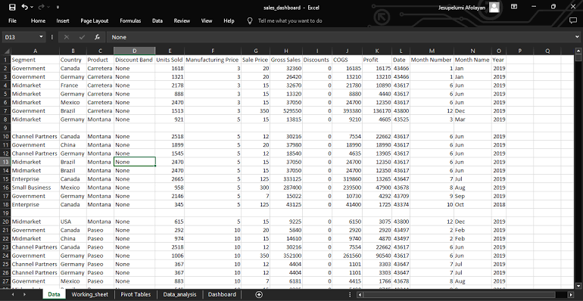

# 6. Setup Instructions

• Prerequisites:

* Python 3.x
* Flask
* Internet connection

• Installation Steps:

1. Clone the project files
2. Install Flask using pip
3. Place Tableau links in index.html
4. Run Flask server
5. Open http://localhost:5000

# 7. Folder Structure

/iRevolution

├── /templates

│ └── index.html

├── /static

├── app.py

└── README.md

# 8. Running the Application

* Frontend:

Use a browser to view embedded dashboards.

* Backend:

Run Flask server using python app.py

1. **API Documentation**

No custom APIs were developed.

1. **Authentication**

No authentication was implemented. Future versions can include user login.

# 11. User Interface

* Interactive dashboards
* Filters for year, model, country
* Responsive layout

**12. Testing**

Tested performance in Tableau and Flask server routing.

# 13. Screenshots or Demo

Below are visual proofs from the Tableau dashboards used in the project:

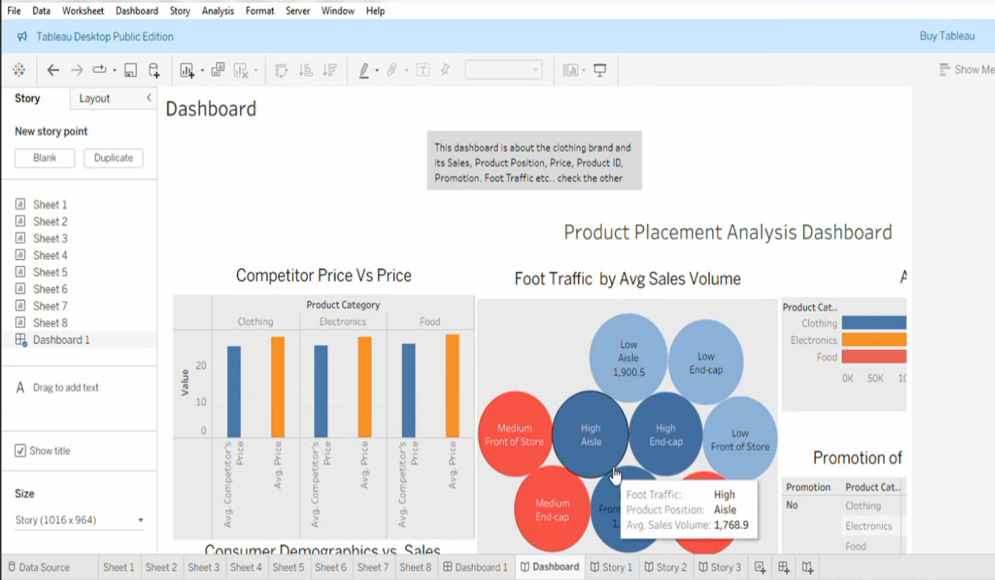

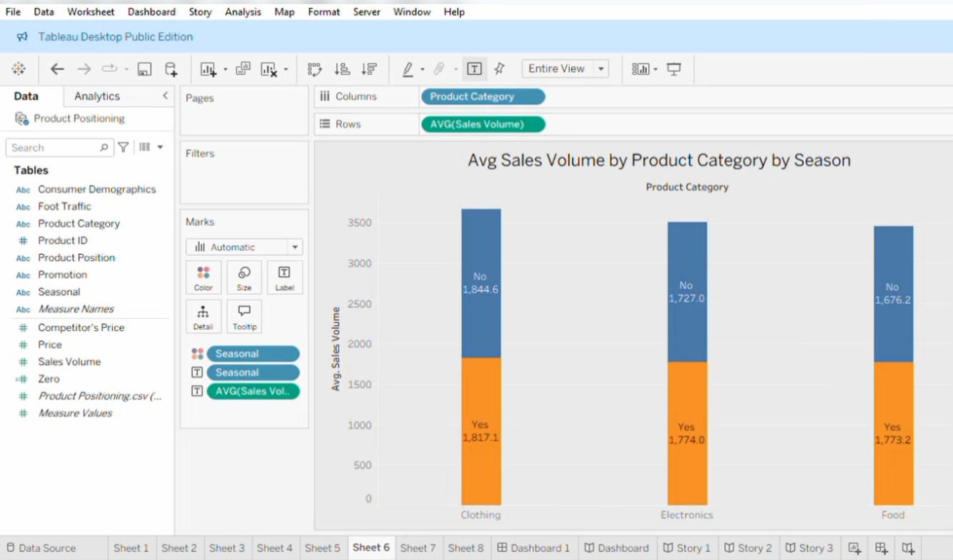

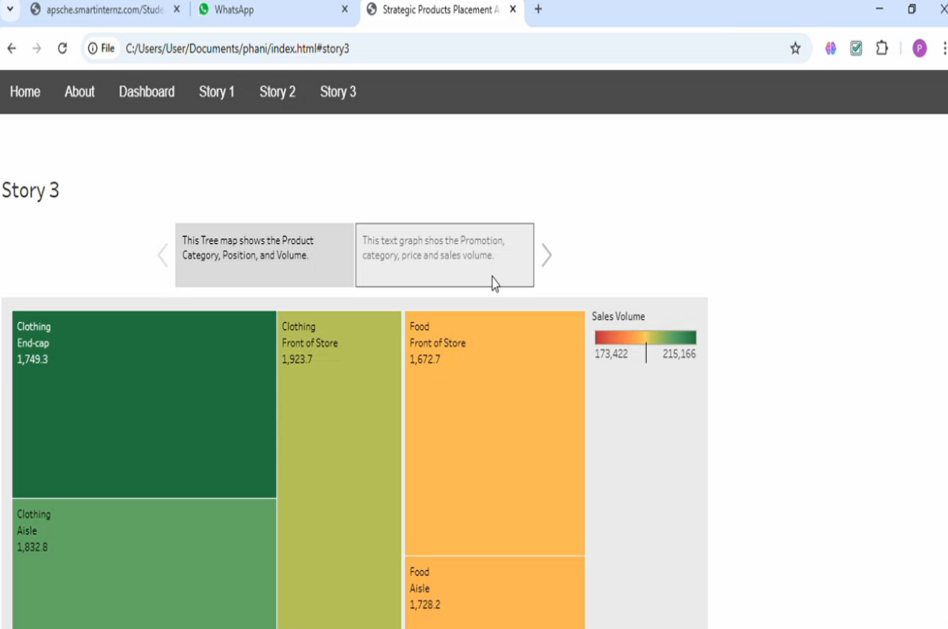

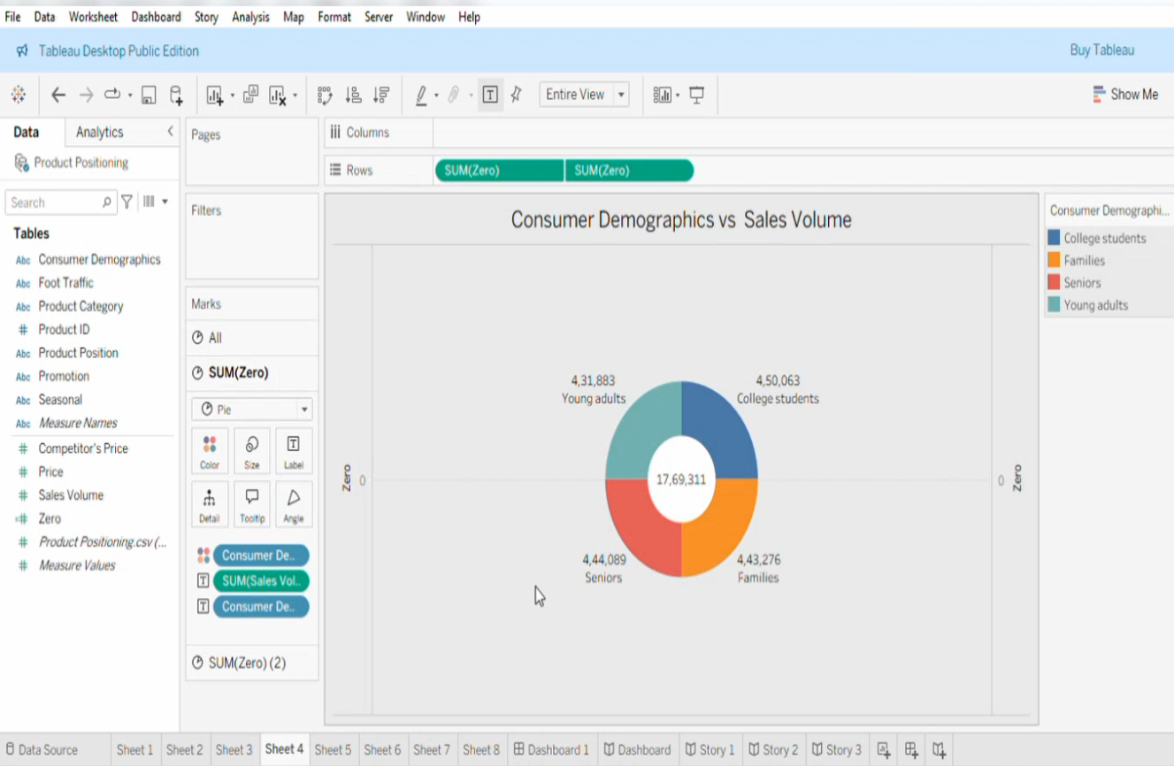

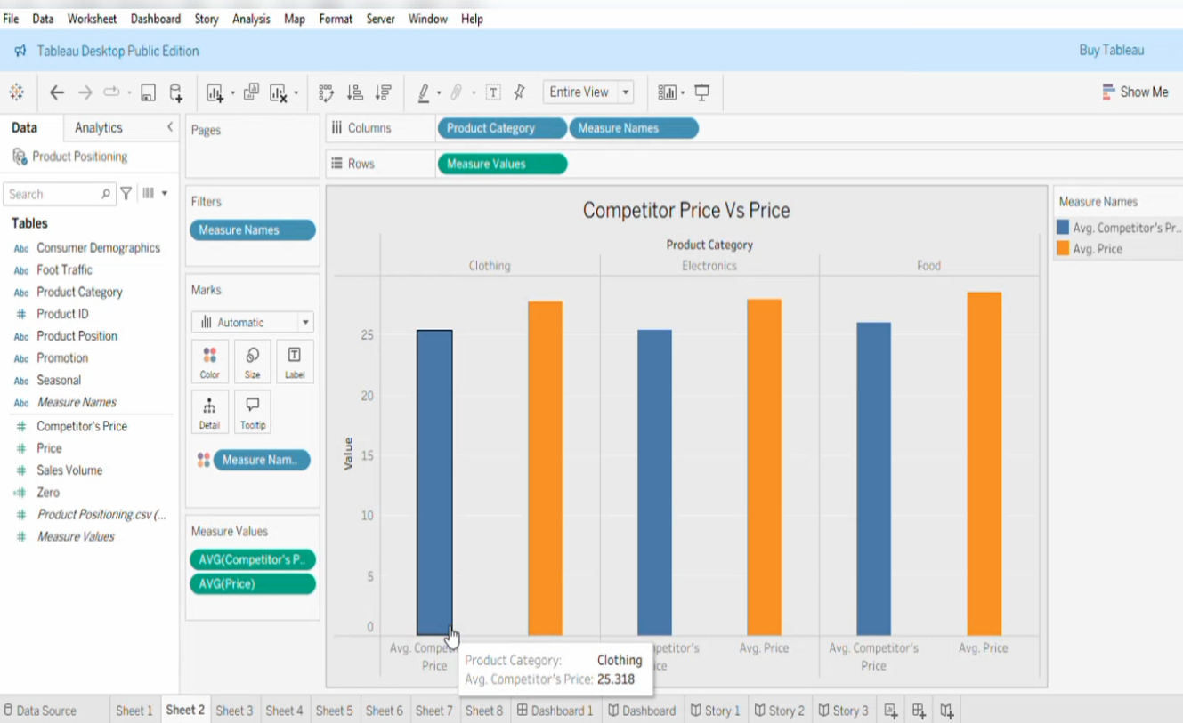

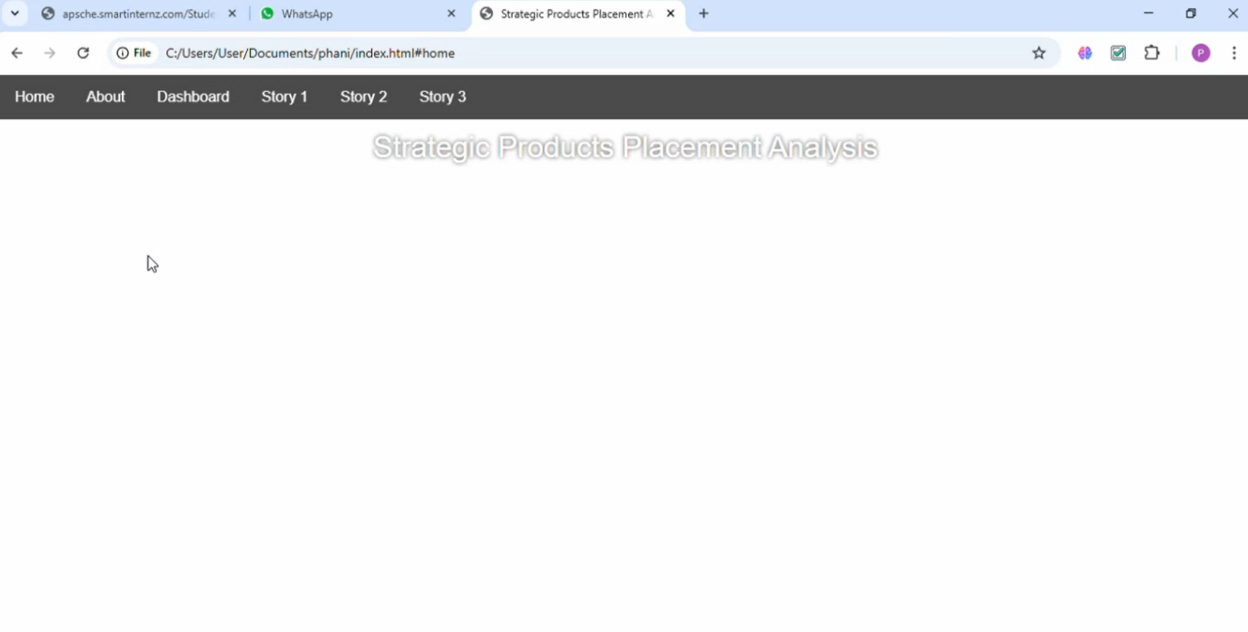

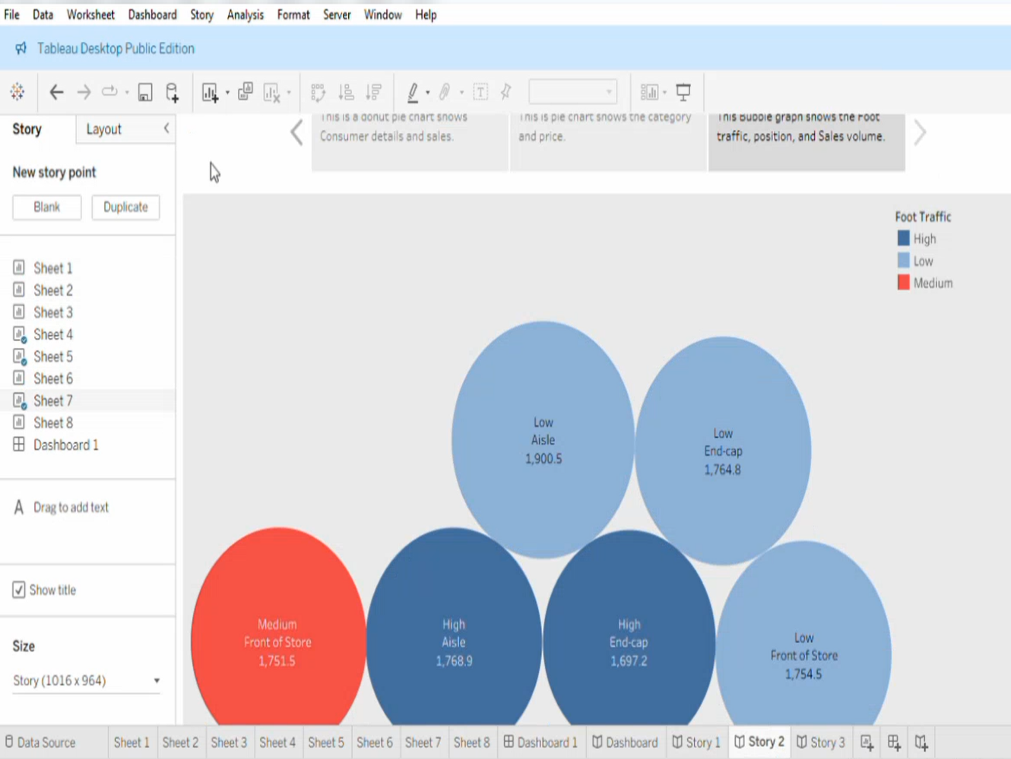

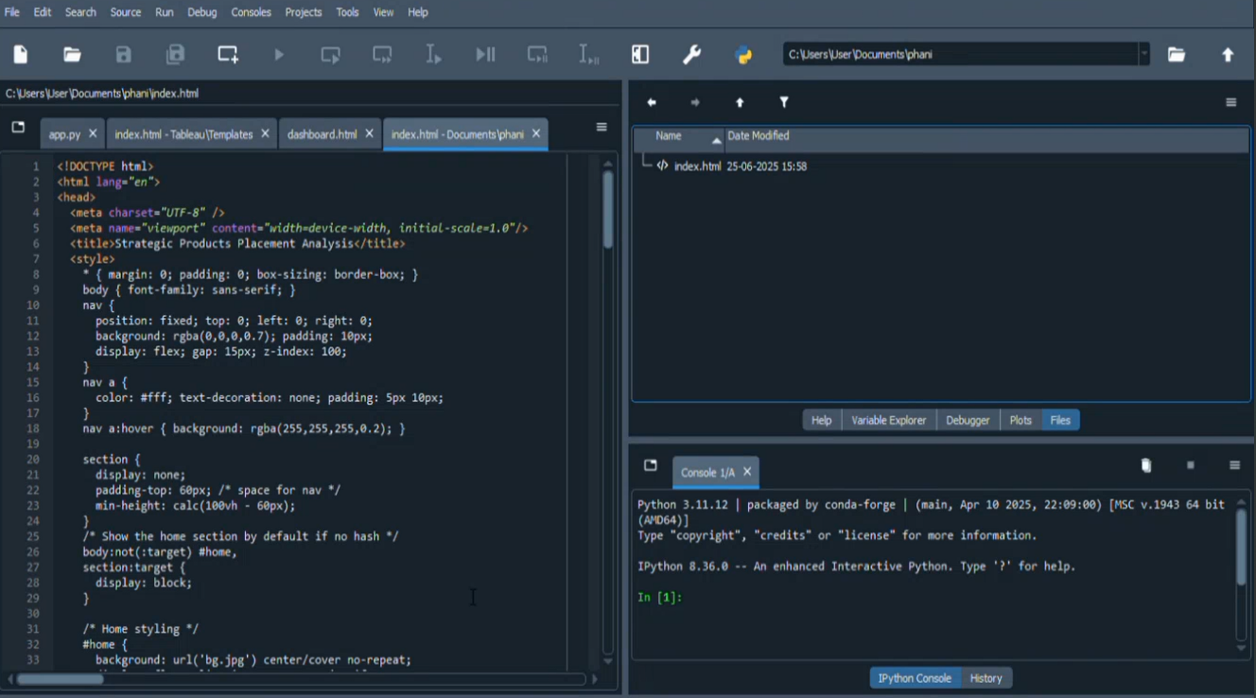

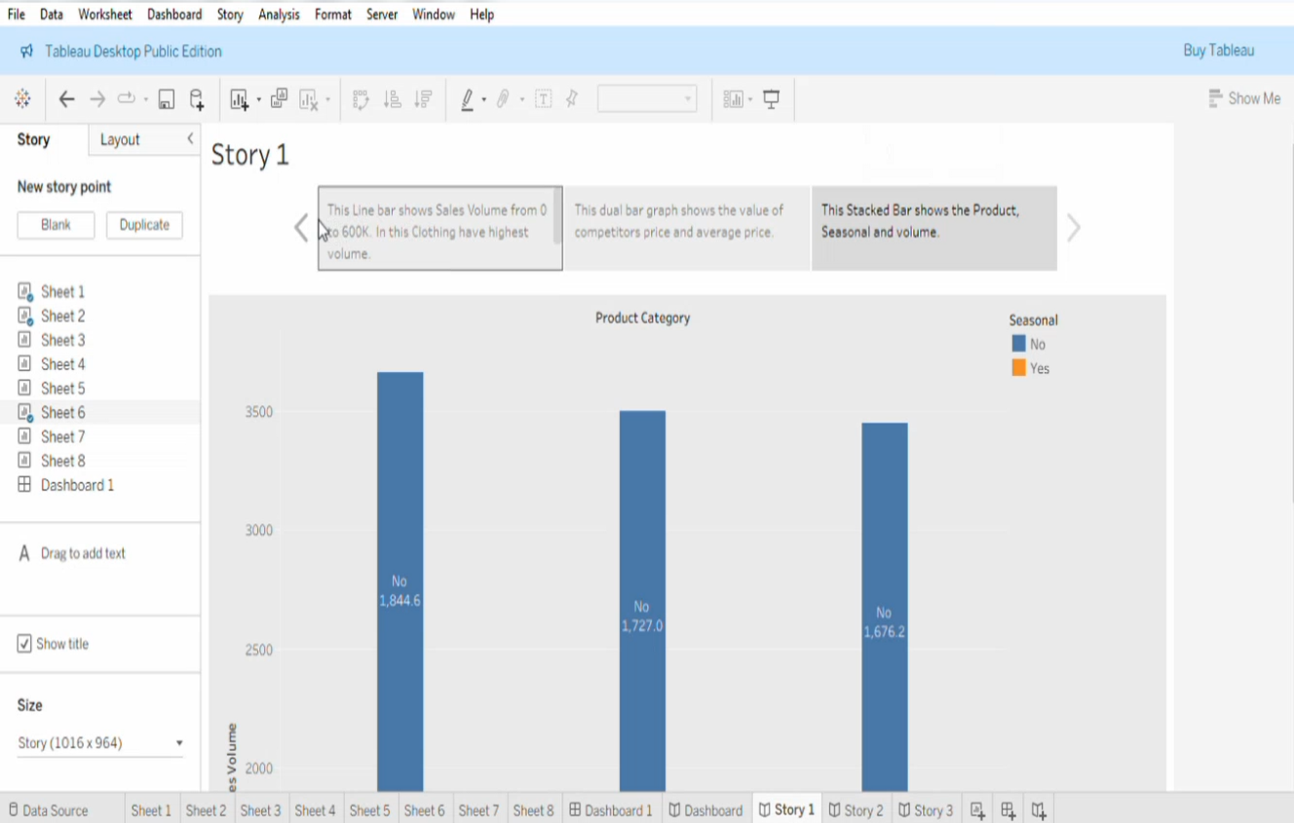

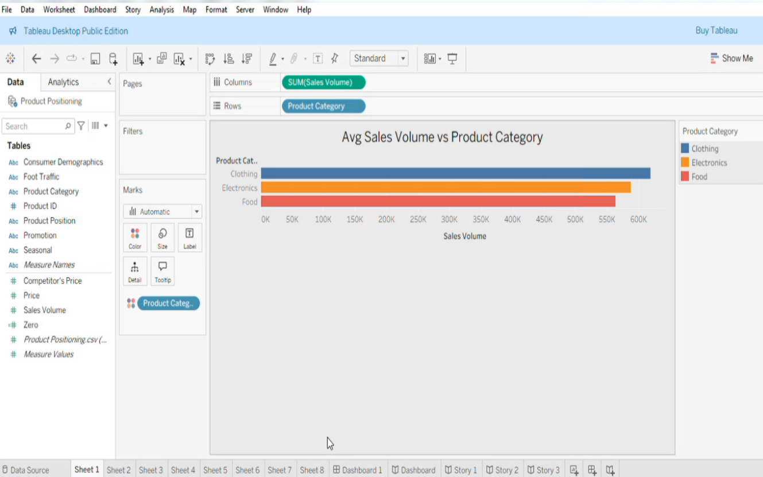

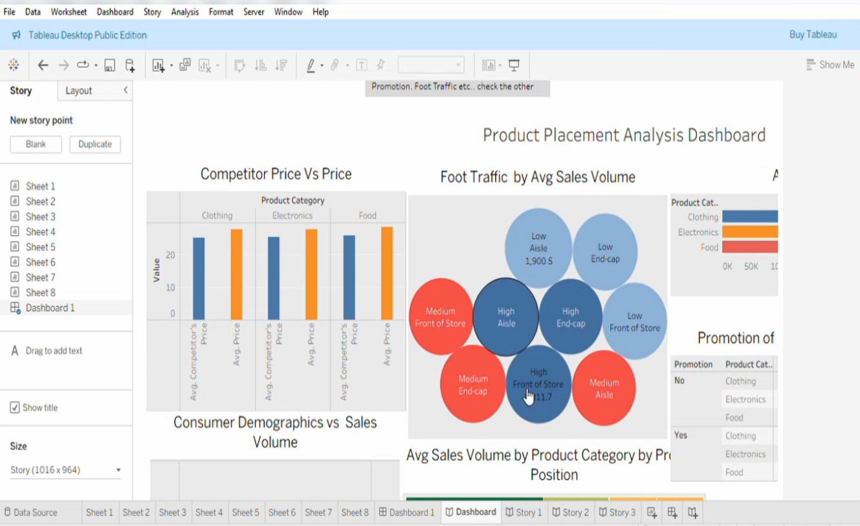

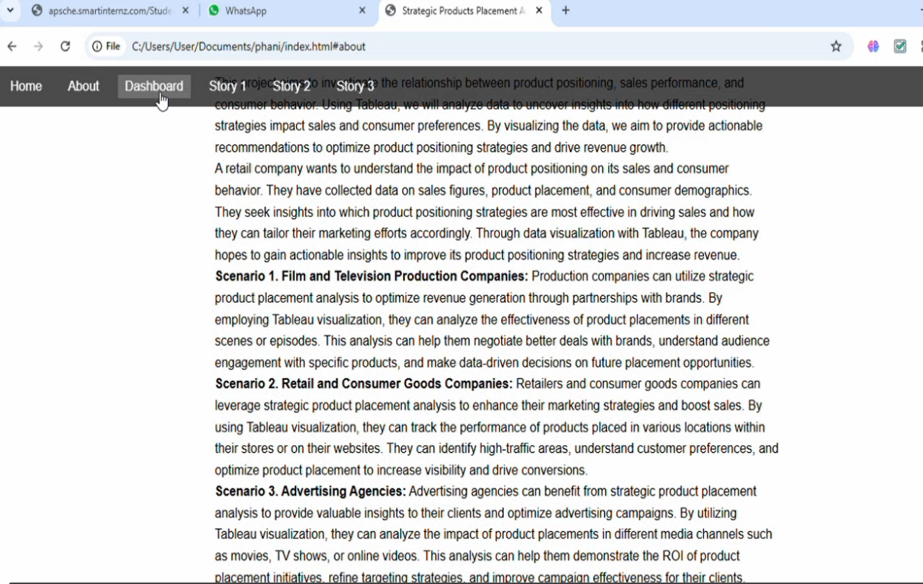

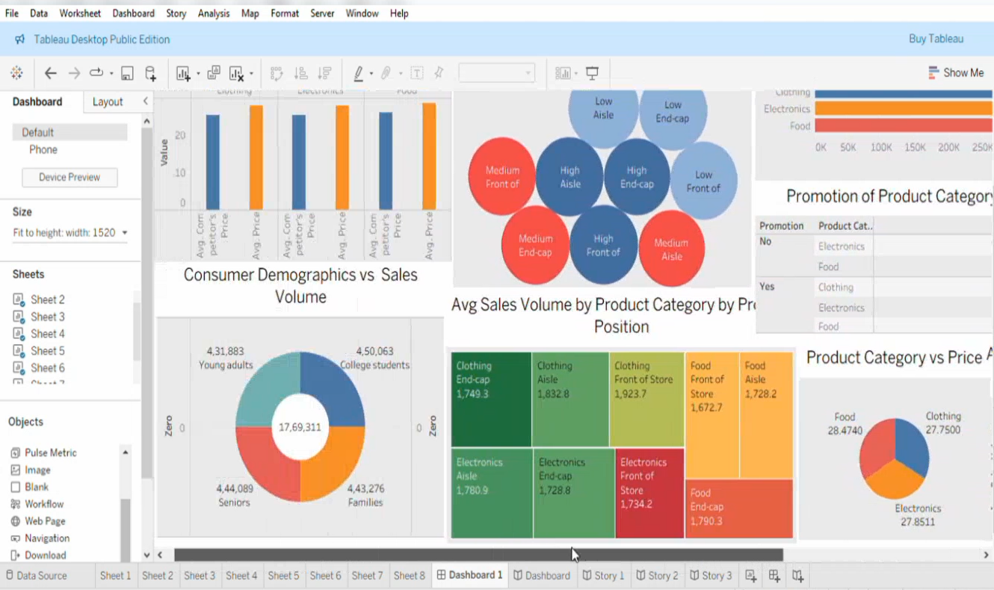

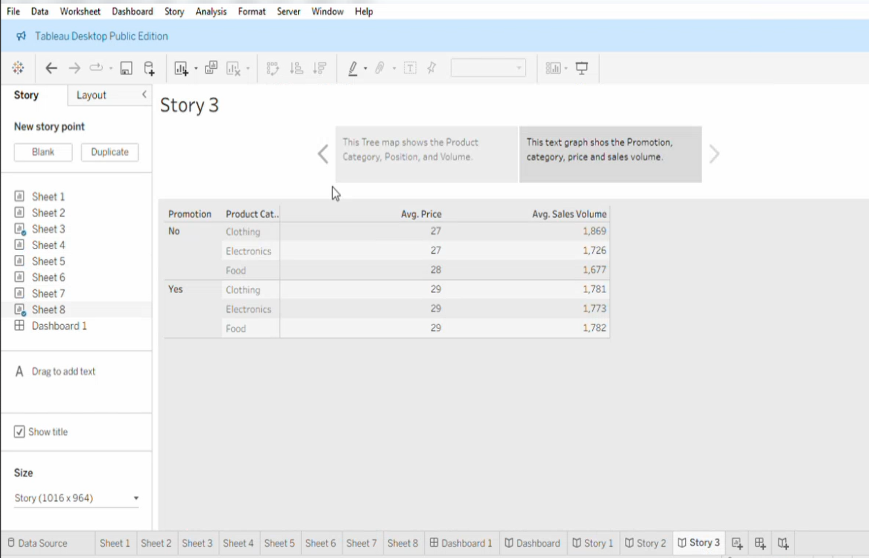

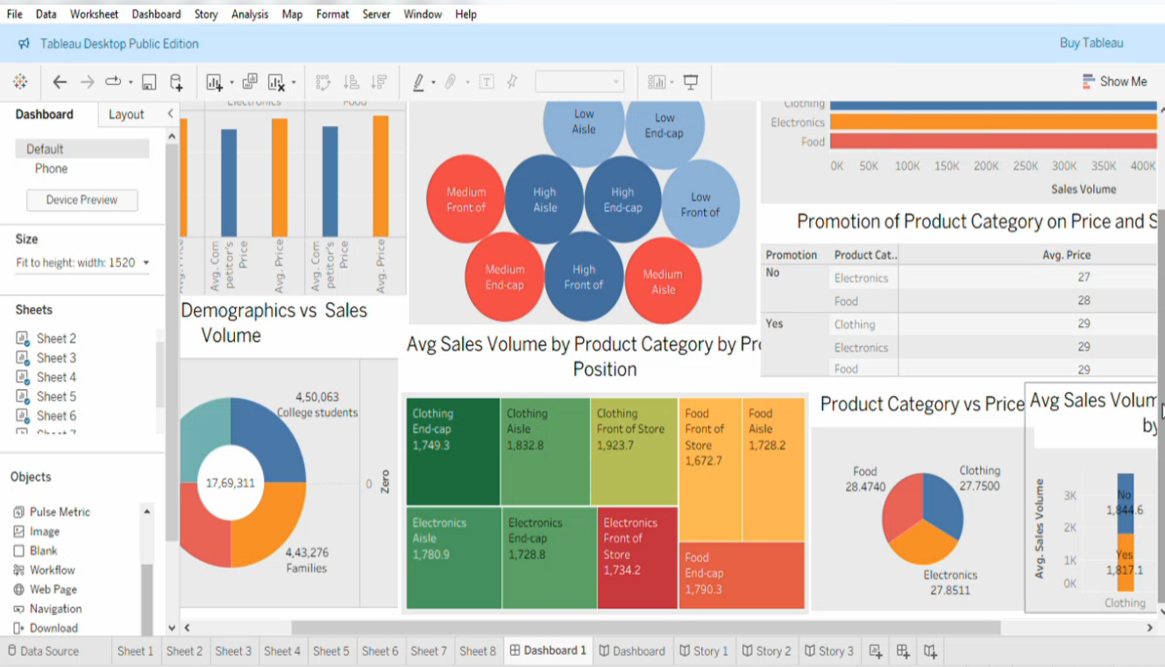

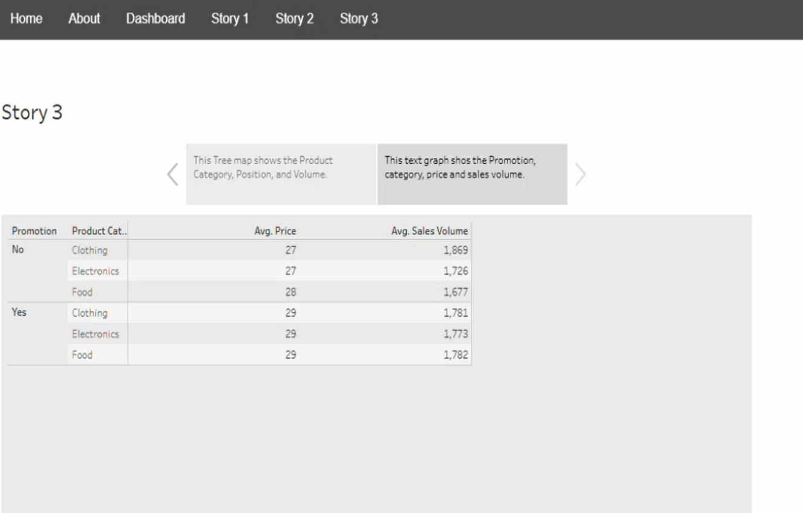

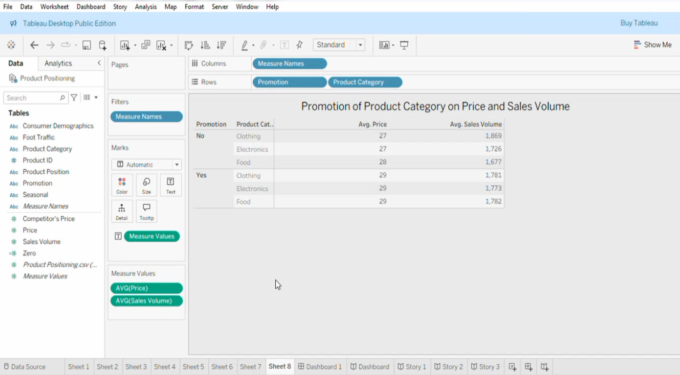

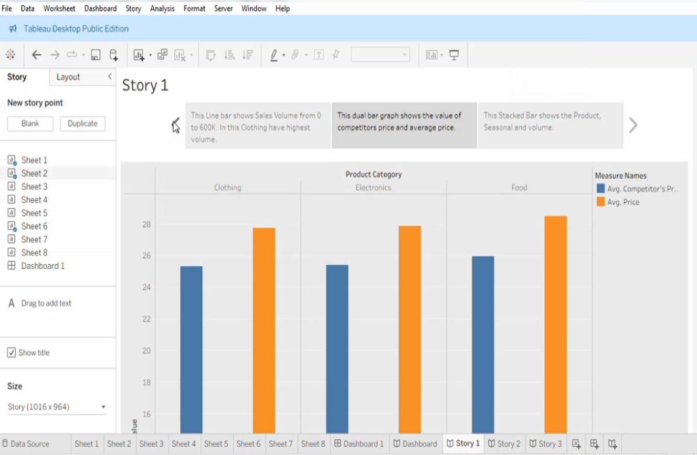

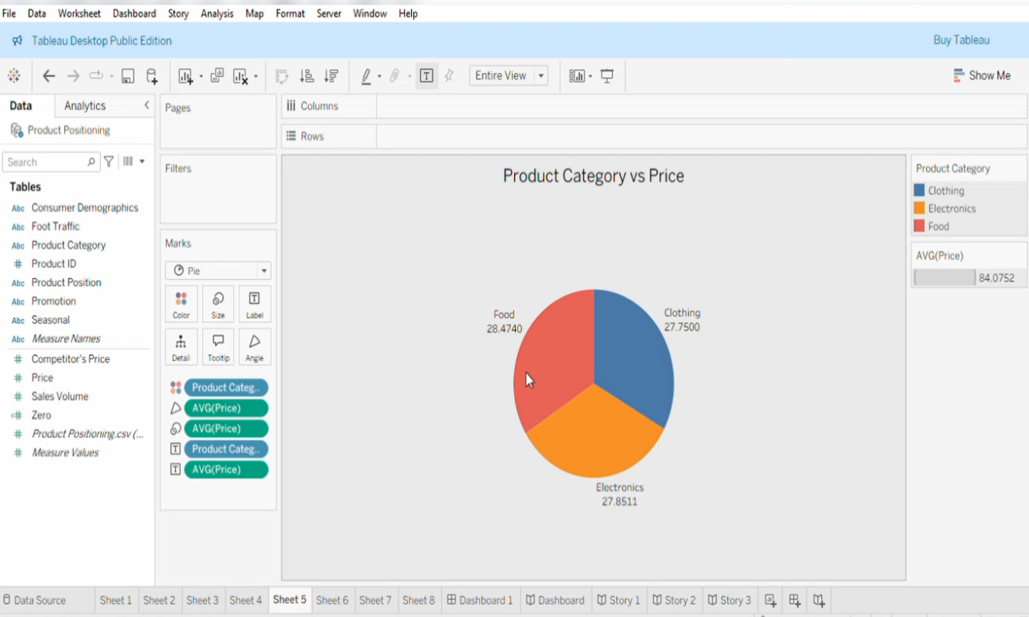

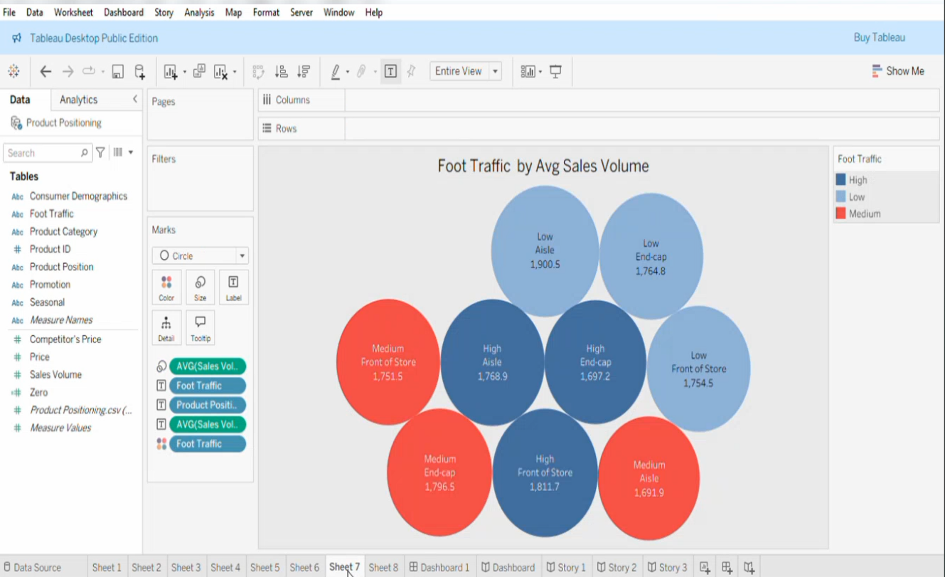

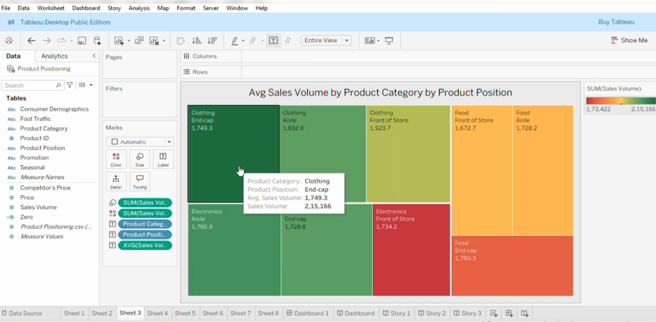

# 14. Known Issues

* Dashboards rely on internet connection
* May load slower on low-end devices
* No authentication

# 15. Future Enhancements

* Add real-time data APIs
* Host on cloud platform
* Compare more brands
* Add chatbot and user login system